Source https://www.getyourguide.com/paris-l16/eiffel-tower-guided-tour-t403886/?ranking_uuid=2d1eceb9-9b48-4dbf-8c14-ff0dc3ba1d68
__________________________________________________________

Skyline Legends Experience: Eiffel Tower Guided Elevator Tour
__________________________________________________________
★★★★★ 4.7/5 20 reviews

Add to wishlist ♡

__________________________________________________________

1 day | €95 per person

🏕  Image | 🏕  Image | 🏕  Image | 🏕  Image | 🏕  Image | 🏕  Image

__________________________________________________________
About This Tour
Step into the story behind Paris’s most iconic landmark with a guided Eiffel Tower experience that elevates your visit beyond ordinary sightseeing. Accompanied by an expert guide, you’ll uncover fascinating details about the tower’s history, engineering, and cultural significance while enjoying sweeping views of the French capital from above. For those seeking an even more romantic perspective, you can optionally add a Seine River cruise to admire historic monuments from the water.
__________________________________________________________
What’s Waiting for You
- Duration: 2–3 hours
- Group Size: Standard guided group
- Languages Available: English
- Guide: Professional English-speaking guide
- Transportation: Not included
- Meeting Point: 62 Avenue Suffren, 75015 Paris, France (GetYourGuide shop, 8–10 min walk from the tower)
- Season: Available year-round
__________________________________________________________

Check Dates & Availability

Select participants: (Age 99 and younger) - 1 +

Choose date:
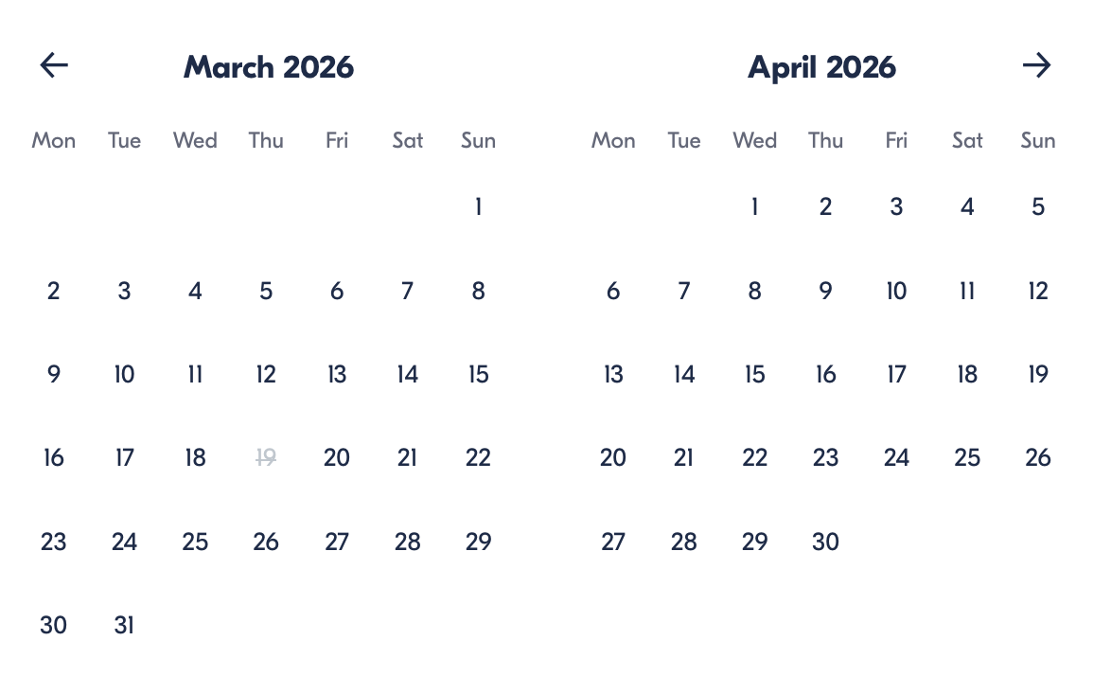

Check Availability

opens:

Participants: 1 March 16, 2026

Skyline Legends Experience: Eiffel Tower Guided Elevator Tour

- Duration: 1 day
- Offered in: English
- Starts at: 6:00 PM

Cancellation:

- More than 24 hours before start — Full refund
- Less than 24 hours before start — No refund

Price breakdown: 1 Participant x €95

Total: €95

The total price includes all taxes and fees.

Add to cart Book now

__________________________________________________________
Tour Features
- Guided Tower Experience: Learn the secrets of the Eiffel Tower’s construction and legacy.
- Elevator Access: Reach the second floor or upgrade to the summit for ultimate views.
- Panoramic Paris Views: See landmarks such as the Louvre, Sacré-Cœur, and Arc de Triomphe from above.
- Optional River Cruise: Add a scenic Seine cruise to admire historic monuments from the water.
- Flexible Timing: Cruise can be used any day after your tower visit.
__________________________________________________________
Eiffel Tower Discovery Experience
Arrive at the designated meeting point near the Eiffel Tower, where your guide will greet you and provide your tickets before the tour begins. From there, your guided experience starts with fascinating stories about the tower’s origins, design, and evolution into one of the world’s most recognised landmarks.
Take the elevator up to the second-level viewing platform, where you’ll enjoy breathtaking panoramas across Paris. If you’ve selected summit access, continue higher for an even more spectacular perspective overlooking the city’s skyline.
Your tour concludes on the tower itself, leaving you free to continue exploring at your own pace. If you selected the optional Seine cruise, you can board it later at a time convenient for you and glide past famous riverside landmarks and historic architecture.
__________________________________________________________
Included in Price
- Elevator access to the second floor (if selected option)
- Summit elevator access (if selected option)
- Guided Eiffel Tower tour in English
- Optional 1-hour Seine River cruise (if selected option)
__________________________________________________________
Not Included
- Transportation
- Food and drinks
__________________________________________________________
Who Should Avoid This Tour
- Travellers using wheelchairs
- Visitors with significant mobility limitations
__________________________________________________________
Important Trip Info
- Meeting point is at the tour shop — not the Eiffel Tower entrance.
- Security and elevator queues may cause delays on busy days.
- Summit visitors must queue again on level two for the summit elevators.
- Tour length may vary between 1.5 and 2 hours, depending on wait times.
- Exiting the tower after the tour takes about 20–30 minutes.
- Large bags, glass items, weapons, padlocks, and non-folding strollers are not permitted.
- Cruise (if selected) departs near the tower and usually runs until about 22:30, depending on the season.
__________________________________________________________

Cancellation Policy
For All Participants:

- More than 24 hours before start — Full refund
- 24 hours or less before start — No refund
__________________________________________________________
What Our Clients Are Saying
Overall rating  4.7/5  ★★★★★  Based on 20 reviews | Review summary  Guide 4.5/5  Transportation 4.6/5  Service 4.7/5  Organisation 4.5/5

Filter  - All traveller types  - Couples  - Group of friends  - Families  By star rating  - All star ratings  - 5 stars  - 4 stars  - 3 stars  - 2 stars  - 1 star | Search reviews (e.g., guide)  Sort by:  - Top picks  - Latest reviews  - Best ratings  - Lowest ratings
__________________________________________________________
★★★★★
Daniel W. — United States
An incredible experience! The guide made the tower’s history come alive, and the views from the top were unforgettable.
★★★★★
Luc B. — France
Fantastic tour with fascinating facts and stunning scenery. Seeing Paris from above was breathtaking.
★★★★★
Isabella R. — Spain
Perfectly organised and informative. The summit view alone was worth it.
★★★★★
Marco L. — Italy
An unforgettable highlight of our Paris trip. The guide was knowledgeable and engaging.
★★★★★
Ying Z. — China
Wonderful experience with amazing panoramic views. Highly recommended for first-time visitors.
See more reviews
__________________________________________________________

Meta tags

Page - Skyline Legends Experience: Eiffel Tower Guided Elevator Tour

Title: Skyline Legends Experience: Eiffel Tower Guided Elevator Tour | Travellio Global

Description: Discover Paris from above with a guided Eiffel Tower tour including elevator access and an optional Seine cruise. Enjoy panoramic city views while learning the tower’s history from an expert guide.

H1 - Skyline Legends Experience: Eiffel Tower Guided Elevator Tour
__________________________________________________________

